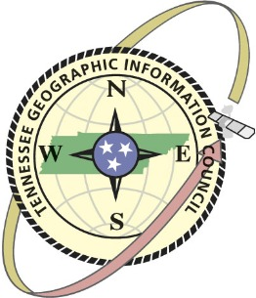

CALL FOR PRESENTATIONS FOR THE

2016 Eastern Regional TNGIC Meeting

**October 7, 2016**

**at the University of Tennessee Agricultural Campus, Knoxville, TN**

Sponsored by the Tennessee Geographic Information Council (TNGIC) and

GeoNET, Knoxville Area GIS Users Group.

Submit an abstract for a presentation at the TNGIC East Tennessee Regional GIS Conference, a free event that brings our communities together to learn from each other and build on GIS technology. This event will provide hands-on demonstrations of GPS and GIS technologies as well as cartographic design.

**Submissions should include**

* Author/Presenter Name(s)
* Email
* Phone Number
* Presentation Title
* Brief abstract (approximately 100 words)

**Please submit presentations** by September 15, 2016

**Submit presentation information** to Mike Meyers, UT County Technical Assistance Service, at [mmeyers@utk.edu](mailto:mmeyers@utk.edu)

**For more information** call Mike Meyers at 865-974-1080 or Ray Boswell, Conference Chairman, at 865-273-3466.

**Presentation format and guidelines:**

* Presentations will be moderated with each presenter allowed 20 minutes
* LCD Projectors will be provided and laptops with Powerpoint available. You may bring your own laptop.
* Presentation abstracts will be published on the TNGIC website and conference agenda website.
* Vendor presentation slots are available.